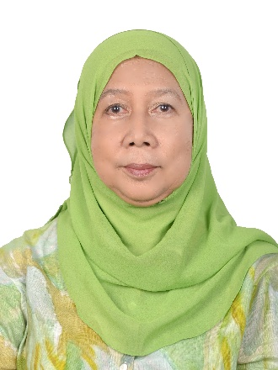

Dato’ Dr Tengku Aizan Tengku Hamid holds a PhD in Human Development and Family Studies with a minor in Gerontology from Iowa State University. A pioneer in the field of gerontology in Malaysia, she brings over 30 years of experience in ageing and social policy. In 2002, she founded a multidisciplinary research centre on ageing, which evolved into the Malaysian Research Institute on Ageing (MyAgeing®) in 2015. She served as its founding director until 2020, driving significant progress in research, education, and policy development.
Dr Tengku Aizan has led and contributed to over 80 research projects as a principal investigator, co-investigator, and consultant for both national and international agencies. Her leadership and advocacy have earned her numerous recognitions, including the conferment of the title Datuk in 2018 and the Anugerah Wanita Warga Emas in 2022. She played a pivotal role in shaping the Kuala Lumpur Declaration on Ageing, adopted by ASEAN leaders in 2015.
A Fellow of the Academy of Sciences Malaysia and The World Academy of Sciences (TWAS), she serves on various national and international advisory boards, including Japan’s HAPI Award Committee, the National Transfer Accounts (NTA) global network, and the Asia-Pacific Consortium on Active Ageing. In 2019, she joined the Board of the Private Pension Administrator Malaysia as an Independent Director and was appointed Chairman of the Board in July 2024

